To successfully use MyWhidbeyHealth Patient Portal and prevent issues with login, you must:
- Be a patient of WhidbeyHealth Medical Center or Clinics
- Ensure you are on the correct Portal Log in page. The URL is: https://mywhidbeyhealth.org.
- Check that your username and password are typed in correctly.
- Use a supported device that is the most up-to-date version available: computer, laptop, cell phone, MHealth App, and/or browser.
- Clear your browser cache and history
- Ensure your computer/laptop or mobile phone does not have any security settings that would prevent it from accessing the portal URL.
- Disable pop-up blockers/VPNs
- Disable any password auto-fill software/saved passwords
- Save “mywhidbeyhealth.org” in your browser for easy access to the portal.
- Delete the enrollment/welcome email after use.
Device Specifications:
For the best user experience when accessing the Portal, our vendor recommends a Windows 10 device (PC or Laptop) or higher running the latest version of Google Chrome as the users' default browser. Microsoft Edge and Mozilla Firefox are also supported. Safari is recommended for Apple/iOS devices.
RAM | OS | Recommended Browser
8 GB+ | Windows 10 + | Google Chrome (most recent version)

Mobile Devices:
Device | OS
iPhones (All Models) | iOS 16+
Android (All Models)  Note: We do not support using Android 15's new "Private Space" feature | 13.0+

Tablets:
For the best user experience when accessing the Portal, the vendor recommends the latest version of Google Chrome as the users' default browser on all non-iOS devices. The minimum screen resolution for all tablets is 1024 x 768. Also, the vendor recommends using the device’s default resolution in Landscape mode as per device.
Windows:
Devices | Display Size | OS | Recommended Browser
Windows 10 Tablets | 9”+ Screen | *Windows 10+ | Google Chrome (most recent version)

Apple:
Devices | OS | Recommended Browser
iPads (All Models) | iPadOS 16+ | Safari (most recent version)

If you are not using the most up-to-date version of your computer’s operating system/browser version, an outdated MHealth App, or an unsupported browser such as Firefox Focus, you will be unable to access the portal webpage.

MHealth Mobile App
You can access your MyWhidbeyHealth account using the MHealth mobile App by using a smartphone or tablet device that runs Apple iOS version 10 or higher or Android version 5 or higher. We recommend always keeping your devices updated to the highest operating system version for the most optimal Patient Portal user experience. The MHealth App is a shared App, which means other Healthcare organization use the same App for their Patient Portals. These are entirely separate portals that operate independently and require individual login credentials for each healthcare facility.

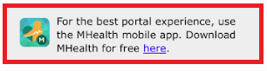
If you access the Patient Portal via entering the URL into a web browser on your device, you’ll be presented with a notification that the MHealth app is available and are brought directly to download the app via the Apple App Store or the Google Play Store, depending on the device you are using.

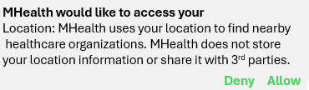
You can also access the App from the Google Play or Apple App stores directly as a free download. Once the app is downloaded to the device you will need to turn on your location services, if not already on, in order to allow the app to locate the Patient Portals nearest to you. The app will prompt you with a message:

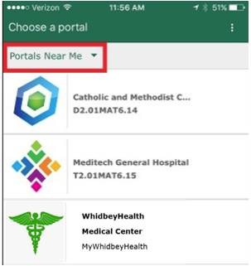
Select Allow. During the initial logon, you will be defaulted to a ‘Near Me’ search. This search utilizes the portal user’s location services to determine the nearest portals within a 124m radius.
In addition to the Near Me option, users also have the ability to search for their portal by My Recent Portals or using the ellipsis (three dots at the top right) and selecting “My Recent Portals.”
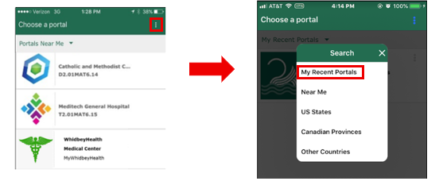
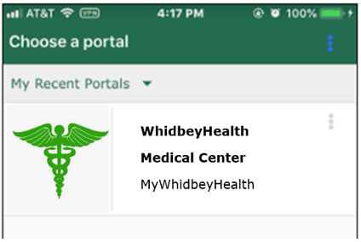
Selecting any entry from the ‘Near Me’ or ‘My Recent Portals’ connects you to WhidbeyHealth’s Patient Portal and then saves that Patient Portal for subsequent use under the ‘My Recent Portals’ option for ease of access.

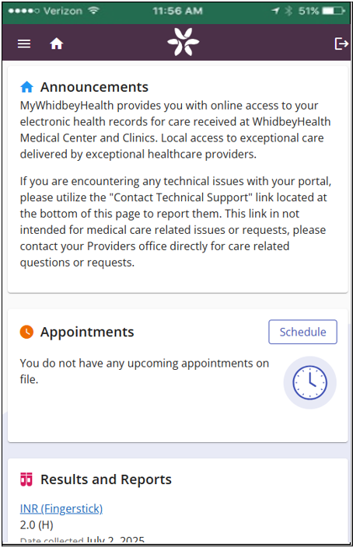
Note: Island Hospital uses the same MHealth Vendor and if you are a patient with Island Health, their portal will display in the “Near Me” search. These are separate portals that operate independently and require individual login credentials for each healthcare facility.
After selecting WhidbeyHealth, you will see the MyWhidbeyHealth Portal log on page. Enter your username and password and select sign in to access your account.

Virtual Visits
To successfully join a virtual visit, please follow these tips, and the instructions below.
If using a desktop computer, laptop, or tablet:
- Disable pop-up blockers.
- Disable any password managers/auto-fill software.
- Use the most updated browser versions available.
- Clear your browser cache.
- Ensure you have a strong internet connection and that you are in a quiet, comfortable place.
- You can join 10 minutes prior to your scheduled appointment time.
- Fill out pre-registration questions after you click on the “join visit” button.
- If you get disconnected during the call, you will have 10 minutes to rejoin.
- You will only be able to join your visit for up to 10 minutes after your scheduled appointment time. Then the “join visit” button disappears, and you will need to call your clinic to reschedule.
- If your provider ends your call, you will not be able to rejoin. Please call your clinic to reschedule.
Instructions
- Navigate to https://mywhidbeyhealth.org
- Log in. If you do not have a MyWhidbeyHealth Patient Portal Account, you will not be able to attend your virtual visit. Please call your clinic to reschedule.
- Under the “Appointments” widget, select “Test Connection” before your visit to ensure you have a good connection. 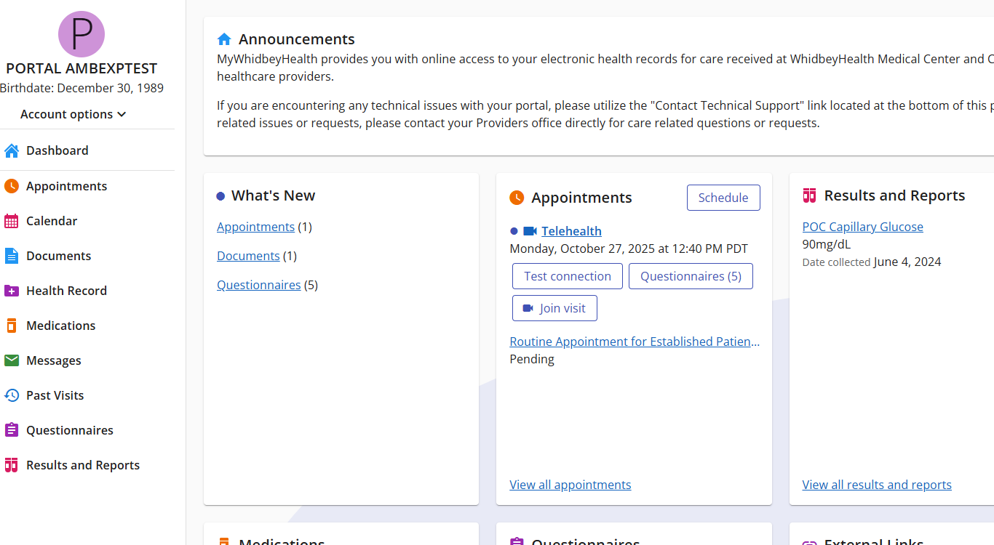
- Under that same “Appointment” widget, select “Join Visit” to review registration information and join the virtual visit. 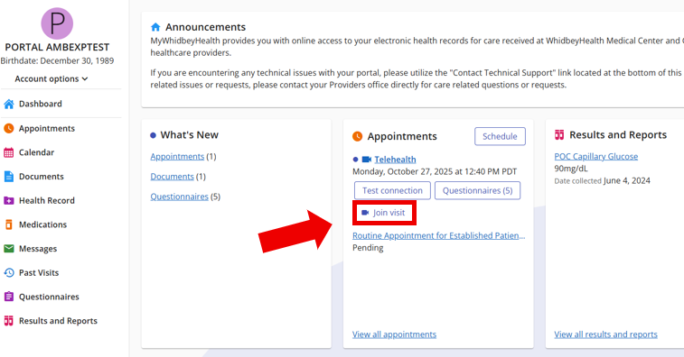
  - A blue loading bar will flash across the top of the webpage, indicating your information is loading. Please wait.
- Review your information (demographics) presented, and update if needed.
  - If you are due, you will be presented with consent forms to sign electronically.
  - Click the blue “submit” button at the bottom of your screen when completed, and you will join your virtual visit.
You can join up to 10 minutes before the scheduled appointment time. If you try to join sooner, the join visit button will not be activated. For additional assistance, please reach out to your Clinic directly and ask to speak with a Patient Registrar.
To view Scanned Results such as Pathology, Echocardiogram, and EKG results:
- Select “documents” from your main menu.
- Select “scanned documents.” Your results will be displayed below. 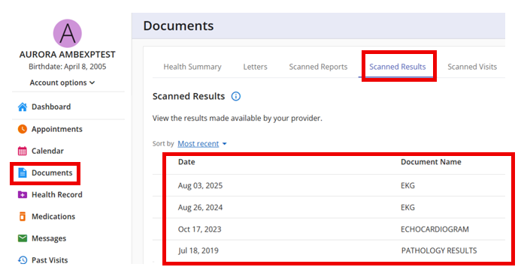
- Click on the document name to view your results. These will open in a new tab/window.
There are other scanned records available in the Documents section, such as consents, letters, colonoscopy reports, EMR Reports, Physician's History and Physical Form, and Discharge instructions (surgery).
To view records such as lab results and office visit reports:
- Click on “results and reports” from your main menu.
- Click on “view report,” this will open in a new tab/window that will allow you to download or print the document. 